**OPTION 1: Edit Poster Text in Your Browser (Chrome or Internet Explorer)**

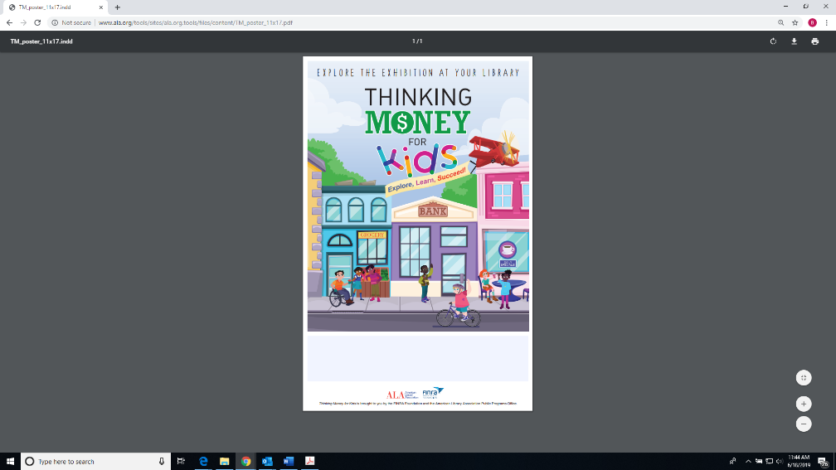

2) From this page, you simply need to click your cursor inside the light blue box.

3) Enter the text you want within the field

Note: You cannot edit the text size, font or color.

4) Print your completed poster.

Here, we will show you how to edit the poster file, but the instructions are the same for each piece.

1) Click the link to open the editable file. Usually your browser will open PDF in a new tab.

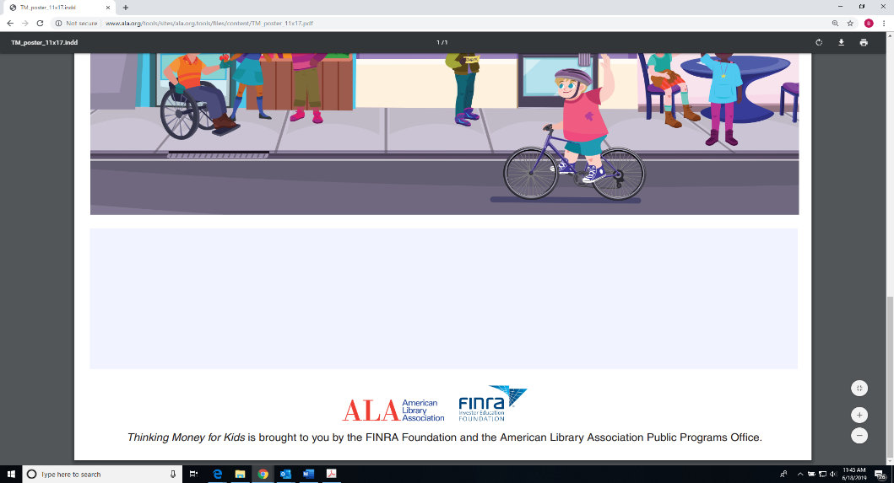

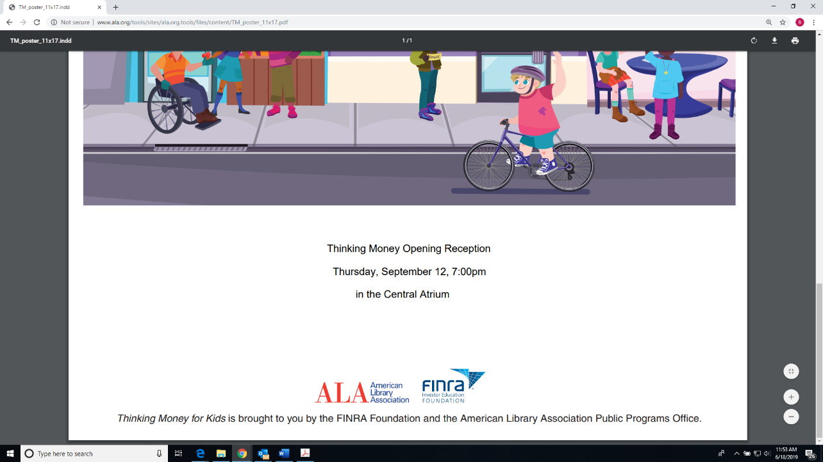

**OPTION 2: Edit Poster Text via Adobe Acrobat**

1) Click the link to open the file. Usually your browser will open PDF in a new tab.

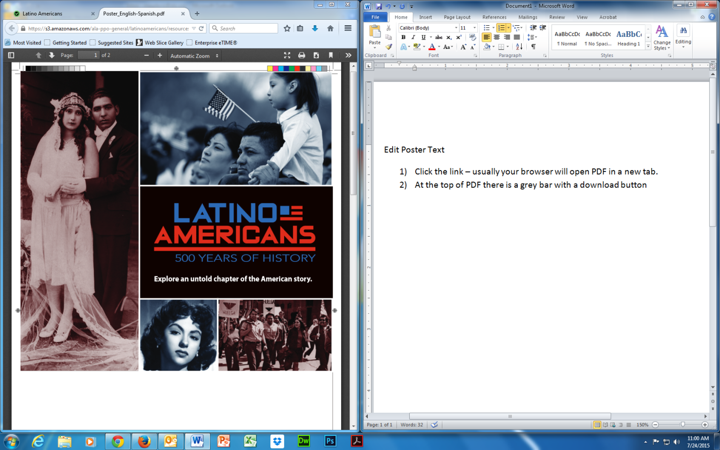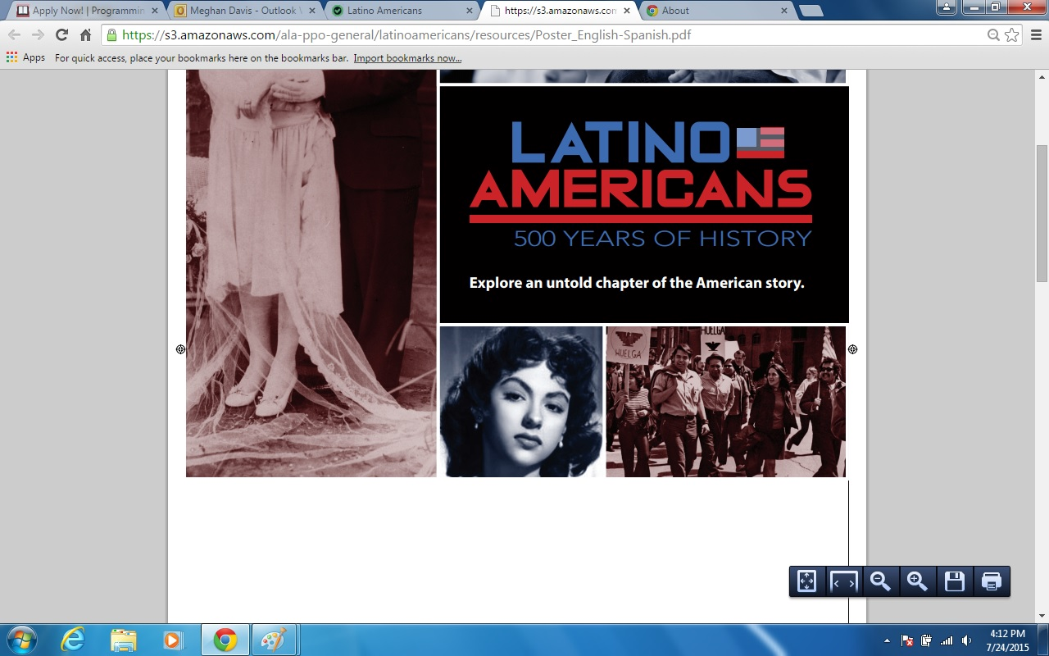

2) Next, you need to open the file in Adobe Acrobat. At the top of PDF there may be a dark gray bar with a download button

**OR**

a gray box in the bottom right corner of the screen with a floppy disc icon.

4) When Acrobat opens, double-click your cursor into the bluish-grey box and then begin to type.

5) When finished, print your completed poster.

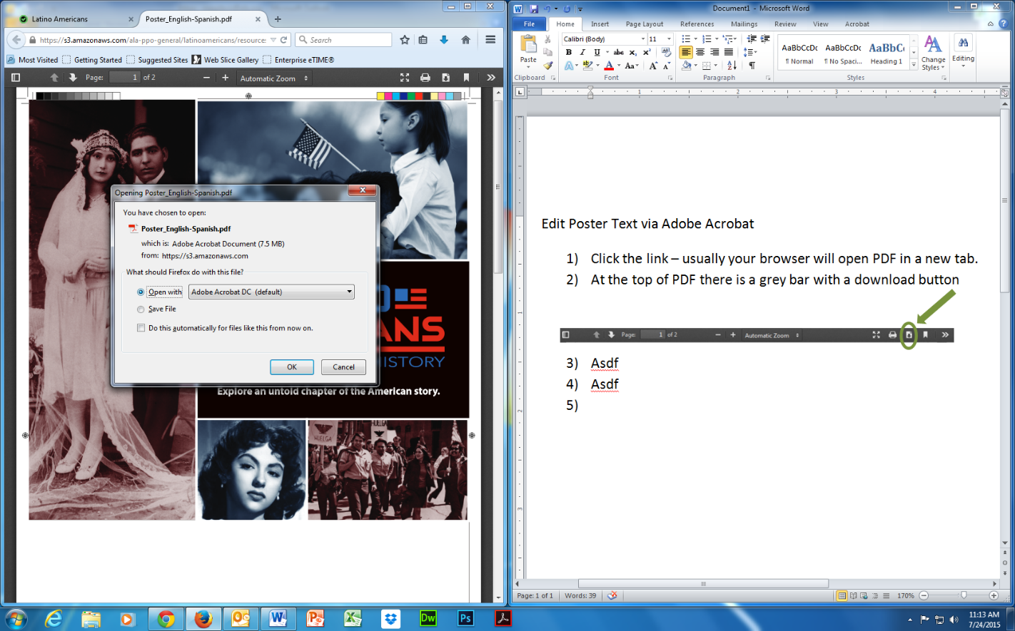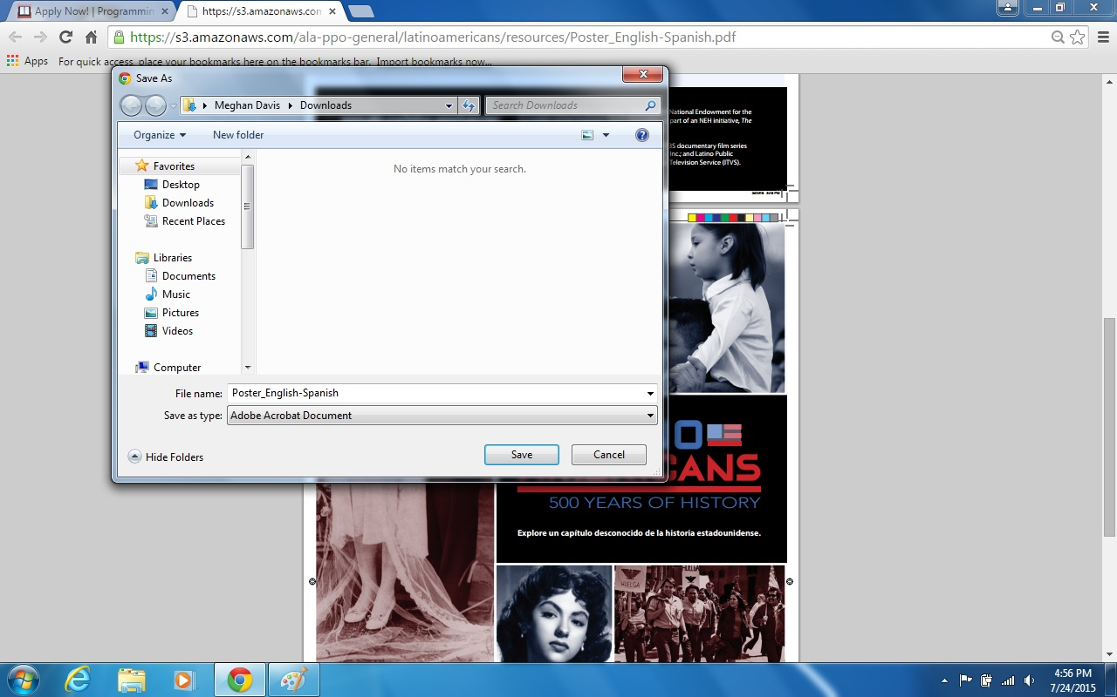

3) If your computer displayed a gray bar on top:

Select “Open with” and then click “OK.”

**OR**

If your computer displayed a gray bar in the bottom right corner of the screen, save the image as prompted, and open it in Adobe. Acrobat.

